# 91907 Project management

## Initial scope and plan

Describe the project, including the context and its purpose:

I plan on creating a homework help question board where students and teachers can choose to ask and answer questions about a range of topics. Have different categories of questions so someone can choose a field they know about to answer questions in. It should be easy to use and functional while also being future-proof and private.

It’ll require people to log in so that everyone can see who asked and answers every question. I'll have an admin page for easily editing everything.

This will be a helpful website that connects people who need help with those who can provide it.

Specifications:

* Users can ask questions, and choose a category to put them in
* User can edit their own questions, content and category
* Users can delete their own questions
* Users can post an answer on any question
* Users can delete their own answers
* Users can choose to see a list of questions by recency, answered or not, and asked by themselves
* Users can also filter any list by category
* Users can log in
* Users can edit their own profiles
* Students can change their Year Level
* Teachers can choose to be changed to a student account
* Admins can choose to be changed to a student or teacher account
* Users can update their username and password
* Users can log out
* Admins and teachers can create new accounts
* Admins can add a category for the questions
* Admins can delete a category

Who will be your stakeholders, explaining why you are using them:

People who generally need help with their homework. I'll be able to find those people easily because in general, all students require help with their studies at some point in their school careers, I know I have and I know every one of my friends has before, so the target audience exists. I will use this audience because they have a problem that I might be able to help with.

The stakeholders I will go back to for feedback regularly are the following people.

Spencer Welsford

Josh Ongley

Hamish Ecroyd

Noah Melish-Temple

Guy Daniels

Software that you will be using, and what it will be used for:

GitHub will be used for saving the project, and backing up my work so I can go back to earlier saves and not lose my work.

Xcode will be used for writing the code.

Xxamp for using PHP and for testing the site.

Trello for managing what I must do while organising the project and for splitting the project up into smaller and easier-to-manage tasks.

Db designer for designing the database, as shown in the use below. 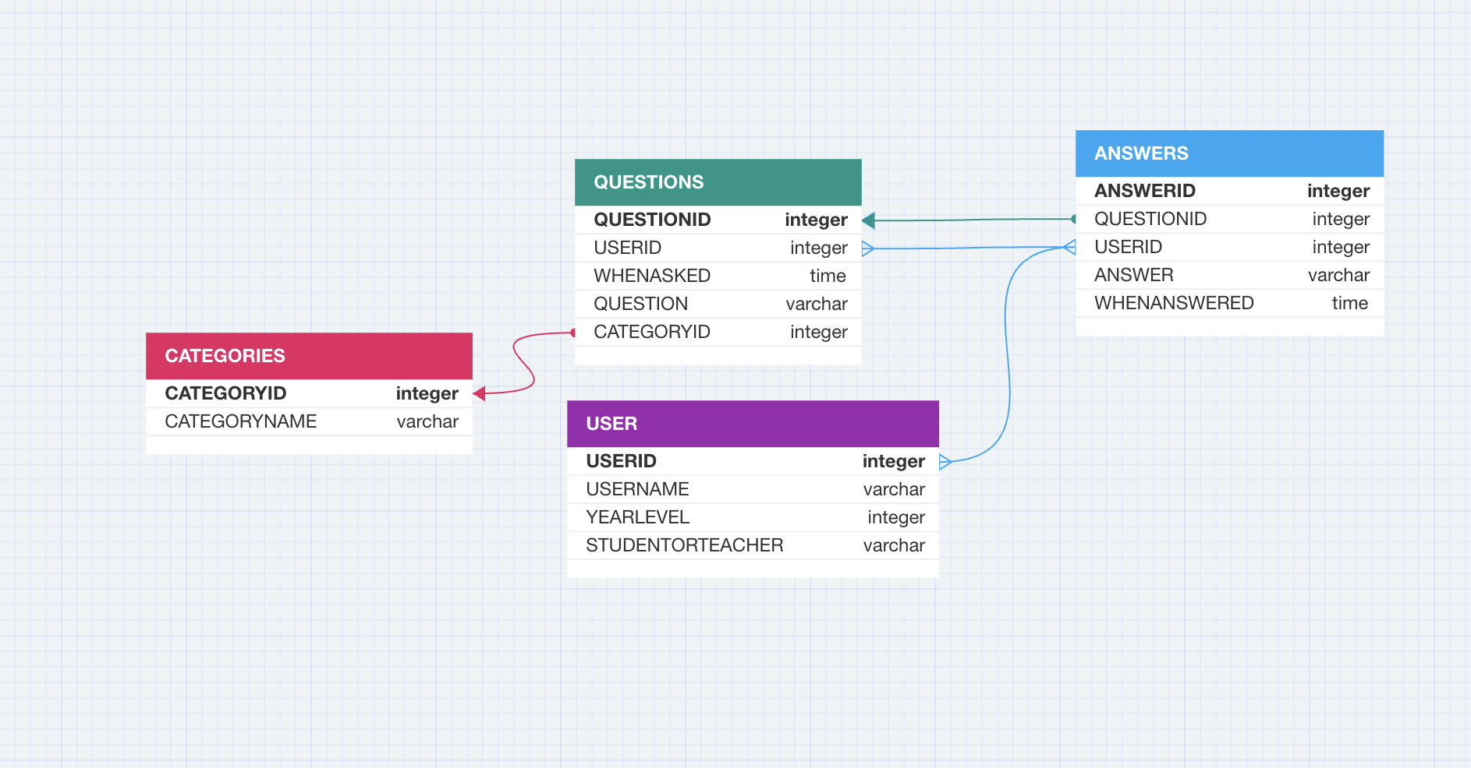

Adobe XD for designing the website, again as shown below.

<https://xd.adobe.com/view/97cef80e-9237-43bb-8e69-3104a13d3e1b-c29d/>

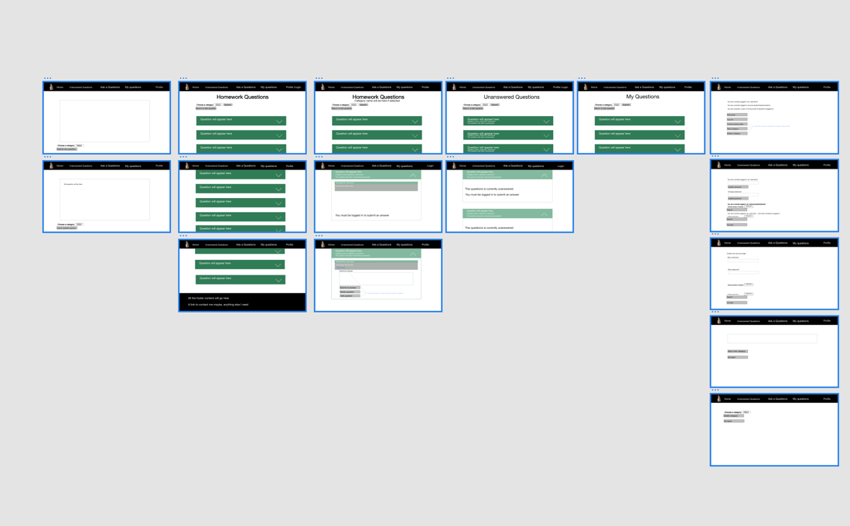

If you are working with anyone else on the project, identify them and what each of you will be working on:

No on my own.

Identify how you will get feedback throughout the project and who it will be from:

I will get feedback from my stakeholders, people in the class, and friends who agree to give feedback.

I will gather feedback around once per week, I will ask one or more of my stakeholders, identified people who I am going to for feedback, see list above, for their opinions on the next steps and improvements that could be made. ‘Around once a week’ because some weeks more work will be done and some weeks much less will be done so in the weeks where nothing has been done since that last time, I requested feedback there would be little point asking again so quickly.

I will record feedback in my notes and use it as a to-do list

How will you manage the project? (This includes version control and code sharing in GitHub, Agile project management recorded using Trello, etc)

I will back everything up in GitHub, and use Trello to manage my project, by first identifying all the small things that need to be done and breaking down the big tasks into manageable things I can get done in one sitting. This way I will be more motivated to get work done.

Below is my Trello board

<https://trello.com/invite/b/FroD1e9a/ATTI66e987a394d9c6ccdcd59d9a83a02a2d1ED37764/digi-project>

Break your project up into components. I.e. smaller parts that you will work on, test and refine.

The first thing I will do is create the header; I'll make links to all the pages I want people to be able to access. These will include, a dropdown list, a login button, and a home button, once a user has logged in the login button will be replaced with a view profile button. The dropdown list will have an unanswered questions button, my questions page where the user's questions have been compiled for them, so they don’t have to search for them, and my answers page where the user's response (answers to other's questions) have been compiled for them to see. If you click on these pages while not logged in, it’ll redirect you to the login page.

Next is the profile page, this just allows you to change your name, and your status as either a teacher or a student, and maybe your year group. The profile button leads here, and you need to be signed to do so. This would link to a database that could be changed. There will also be my questions page where a user can see all the questions they have asked.

The next thing to do will be to build the basic format for my main page, this is where the content will be, the main page will have all the unanswered and answered questions for people wanting homework help. The main home page will have questions ranked based on how recently they were added

I will also have a like or dislike function allowing others to say thanks to people who answered their questions. This will also be stored in the database that includes the questions and answers that users have submitted themselves.

The next big thing I'd do is add a question page. This would be included in the header once you log in. It would take you to another page where you are given the fields to fill out to input a question, this would be linked again to another database and would allow users to input data to it.

I will have three main questions pages, first for all questions sorted by recency, second for unanswered questions, and third for the user who is logged in’s questions

Another big thing I’d must do would be to add and edit this question/response section which would take you to a similar page to the add a question section and allow you to update it. Or it could just let you edit it from whenever you viewed the question.

I'd also need an admin section; this could be accessed for admin accounts using an admin button on the header and would allow the admin to remove questions or responses or remove bad accounts.

I will start by just doing math questions and could go deeper and categorize them into stats, diff, algebra, etc. This would allow me to add another database if it was necessary to make the site more complex.

## Relevant implications (all four – 2 relating to the database and 2 to the digital media outcome):

#### Implication 1:  functionality

Functionality, this is ensuring the general functions of the websites work as expected and work every time. It also means including everything the user would need and want to make the website function the way they need it to. This means catching any errors that cause the website to break, it also means finding any glitches and bugs and removing them. It also means making sure the site works on all browsers and all types of computers and devices such as phones as well. Functionality also means ensuring that the links, buttons, and just everything that is clicked on the screen works perfectly and as expected, ensuring they function. Finally, it’s also important to attempt to make the website load as fast as possible by not making the important things more complicated than they must be.

This is particularly important to my project because I need those people who choose to use my website to be able to use it without further stress. It has been designed to be somewhere a struggling student can go to for schoolwork help from real people rather than the often wrong and sometimes misunderstood google search. The type of person who will regularly use this site will likely be already stressed and does not want any trouble when they try and get an answer to a tricky question, so functionality is extremely important.

I will address this by carefully thinking through the features that my website will have and listening to regular feedback as to whether I have included all that is needed. I will ensure that everything works logically and understandably and that all buys and glitches are fixed as best they can be. I will also do my best to make the code precise and to the point and the database only the size it needs to be and not bigger to make the site load and run quickly. Finally, I will make sure the site cannot easily be broken with error-catching so that the user has the most functional experience possible.

For a list of features look for the top of this page.

Error catching

* Whether a username is acceptable
* Whether any text area or input field is of acceptable length to fit in the database
* Whether any text area or input field is left blank
* If a secure page has been accessed without permission user is redirected
* If an account locked page has been requested while logged out, then user is asked to log in
* Username/password being incorrect will redirect
* If a page produces no results user will be told
* User is told if something that requires being a teacher or admin is blocked.
* If no page is set, recent questions will be set as default
* If unusual characters are inputted into the database, it will accept them.

Most of these include specific alerts to make it easier for the user to understand what went wrong.

##### Implication 2:  usability

Usability is the ease of use of the website and the pages within it. This means that the site should be simple, easy to understand, easy to infer where things might be and how to use them, follow norms and conventions and overall, just very simple and easy for the user.

It is important for my project because when people look for homework answers they are usually already annoyed and stressed out because they have likely just been looking for answers for trying to do it themselves unsuccessfully, which understandably would make them irritable and therefore I think they’d appreciate an easy-to-use website.

I will address usability doing my absolute best to minimize the process of doing everything, reduce the time and clicks needed to post a question and make it as easy as possible to answer questions so that those searching for answers will get them asap. For example, after listening to the feedback I removed a screen that would have asked for confirmation whether to post a question after submit was pressed and instead made it very easy to click my questions and instantly delete it with two clicks in a very simple and logical way, thus reducing the number of clicks needed to post a question by one, overall bettering the experience as asking a question is a much more common occurrence than deleting one.

I will also make sure any places where errors could occur will be taken care of so that whatever the user tries to do will work with no issue. These will include error fixing for usability such as allowing all types of text in the inputs.

Visibility of system status was addressed in features such as the profile/login button which changed depending on whether the user was logged in or not, showing login if the user hasn’t logged in and if the user has logged in then it will display the profile button. Also, I included alerts for successful creation of things that the user wouldn’t immediately see.

Math with real world was addressed when the color scheme of the alerts was chosen, with green for successful alerts and red for problems and errors. The messages were all logical and easy for any user to understand, and the few icons were consistent with the real world. All information was generally displayed in an ordered way, usually by recently.

User control and freedom were addressed in features such as the back buttons. In every page there was a blue link that sent users back to the previous page. Even after the questions were filtered, there is a button that sends you back to a page with no filters. I allow users to delete and edit their questions and delete their answers.

Consistency and standards were addressed with simple things like logically laying out the features, so they were easy for users to find. The same format, structure, and design was used everywhere on the site.

Error prevention was addressed all throughout the process, everything I found that could go wrong was fixed, everything was clearly labeled, but if mistakes were made, I made sure it would be easy to fix all of them. Things like invalid inputs for usernames, passwords, questions, and answers were prevented and then the user was given an error message. These are just a few examples of error catching on this site.

Recognition instead of recall was addressed with dropdown lists for categories and options such as the year level and the occupation instead of text inputs, making the site easier to use for all.

Flexibility and efficiency were addressed with minimization of clicks for all users, keeping things as simple as possible. As well as the sections such as unanswered questions and ‘my questions’ to allow users who know exactly what they want to go there quickly.

Aesthetic and minimalist design was addressed by only putting exactly what is needed on each page, the back-end side was very simple and only included things that were needed. No irrelevant information or features were included, and everything was not messy.

Diagnose and recover from errors was addressed all though the site with alerts sent to users every time an error was detected so they could understand what they were doing wrong.

Help and documentation was addressed with the link to my email at the end of the page so users could contact me if they had any trouble, but I kept the site simple so there probably won't be any issue.

The main way I will ensure the website is usable is by regularly asking for feedback from the five people listed above, and others when it is necessary, this will allow me to understand just how the site feels to outsiders who haven't worked on it themselves and don’t already know what things are supposed to do because they didn’t build them. This should hopefully help highlight the flaws and make it easier to integrate this implication.

#### Implication 3: future proofing

Future-proofing means ensuring that the site and the code are both easy to maintain and update but also timeless in both design and logic. Firstly, it needs to be easy to maintain and update because it will be up for a decent amount of time and is not specific to any time, if in the future more subjects are added to a school, I will ensure that they can be added through the admin panel for example. This site could in theory run forever with new sets of students having accounts made by teachers and using the site to ask and answer questions forever, so the site must be future-proof. For this reason, I will make the design simple, so it's clear and even with changing conventions for how sites should be set out, it will always be easy and logical to understand. I will also address future proofing in the database, both by keeping it simple, only including the tables and rows that are necessary and having simple links between them and by ensuring there is enough room in each of the tables to accommodate data that users might input for the foreseeable future. For example, the database will allow up to 9999 questions, considering the scale I have planned my site for this should be sufficient and will likely not be exceeded, however, if it is, it is also quite easy for an admin to increase the number of questions the database can hold in PHPMyAdmin. I will use this reasoning for choosing the number of inputs each field can hold. I have also made sure to use up to date css and html and make site work on all types of screens.

I will further address this by ensuring every aspect of the database is easy to follow and follows common conventions such as consistently using camel lettering to name everything so that even if I was no longer the admin it would be easy for someone else to operate.

#### Implication 4:  privacy

Privacy means keeping the data of users safe from anyone they wouldn’t want to see or use it. This means protecting the site and the database from intrusion and safeguarding the data if an attack was to happen. This is so important in this project because users will be students wanting a service that helps with their homework, they don’t want to have to worry about whether their data is safe just so they can use such a simple service. It's also important if people are trusting me to keep their data safe that I should do so, especially when data could include things like passwords which could be used commonly across lots of different platforms for a certain person so access to the password here could lead to access to more damaging accounts that certain person owns and may lead to much worse damage than just someone causing minor vandalism to my site. So, keeping personal data safe is very important and this particularly relates to the database, for example when passwords are submitted to my database I will run them through a hash function which means I can only store the hashed version of the passwords rather than the password itself, so anyone who managed to get access to my database without permission would not be able to see the passwords users typed in and submitted but rather a hashed version. I will also further address it by doing things such as informing users that some of their data will be visible to others when they ask and answer questions, and I will do this on the edit profile page so they are warned and can make an informed decision whether to post on the page knowing other can see the information of the user who is doing so. I also considered where the photo I got came from and ensured I had the rights to use it.

## Weekly reviews

Each week you should do a short review of what components you have been working on. This includes issues you have faced, feedback from stakeholders, testing results, etc. Include screenshots of evidence, such as your updated Trello board, the component, code, or feedback.

In the early stages of your project, this will also include screenshots of initial designs, site maps (for websites or apps) and your database design.

### Week 1

Date: 12 March

What I worked on this week:

I have organised my tasks into a Trello board to help me visualise what I must do.

This week I have begun working on the header for my website, adding the different categories/page titles.

I have begun to choose a style for the design, although I may change what I have planned in the next few weeks.

I have begun to mock up the design of the pages.

### Week 2

Date: 19 March

What I worked on this week:

This week I have been working on moving the designs on paper to Adobe xd.

This week I kept working on the basic structure, playing around with the hover function with CSS and trying to get it to work with Bootstrap which proved challenging. Started to put the structure in for my main page.

Was very distracted this week, not to do with Digi, so this week I didn't achieve a lot will try and complete the structure of the main page and all the Adobe XD designs for every other page. Might also look at creating the databases and adding in the first few mock-up questions.

WEEK 3

This week I started by adding the correct accordions and perfecting the way they functioned, I spent a lot of time working out how to ensure only one accordion opened when it was clicked and not all the accordions. Once this was sorted out, I put in a very basic footer, at this point I needed to start cleaning up the code, so to make it simpler I began to move all the parts into their documents and then include them onto my main page using include functions. This tidied everything up a lot, but I could still tidy the questions page up, which was put into loops to ensure everything stayed clean, it also meant the code I needed to display questions was universal and could be moved around and changed slightly for slightly different functions. Next, I began to link into a database, which also required planning. I created the database and had three pieces of information echoed. Currently, I only have information printed from the questions and the user's database.

Another thing that semi-urgently needs to be done is changing of the naming of the database

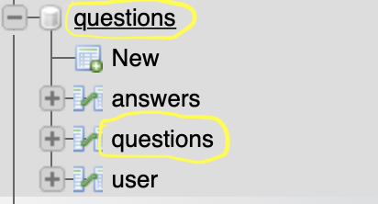

This is causing problems, mainly confusion for me, so the first thing I'm doing next week is changing the naming.

Next week I'm aiming to link the answers database to the questions so that the answers are displayed when the accordions are clicked. I might also then look at either creating more pages, and categories for questions or begin adding the ‘ask a question’ function which I am planning will take me quite a lot of time to complete.

Week 4

This week I planned to change the naming of the databases as shown in the table above, I did not get around to doing this and I plan to do it this week.

This week I started by working out how to display the answers below the question that was asked. This was trickier than getting the questions to display because I had to ensure that the questions were linked to the specific question that the answer related to. This was done by setting the question ID as a variable and pulling out all answers that had a question ID that matched the specific question, for the cycle of the do loop. It worked well and displays every answer that applies to each question, whether there is 1 answer or 100.

Next, I wanted to add a way for users to answer a question, which would involve submitting data into the database, which is something I've never done before, so this involved a lot of learning, and much trial and error. Eventually, It was done, and I had a form that allowed users to write in a question and add it to the page immediately. I also fixed the way the site displayed the username and whether the question was answered or not, I did this using if/else blocks to check the number of rows in the database rather than just using a 1 or a 2. Once I had all this working, I added functionality to some of the buttons on the header so that they would take me to other pages, specifically, I created a page for asking a question. I then had to go and add another form to add questions users submitted to the database and then immediately to the page, I also added a redirect to the main home page.

The next steps will include, fixing the naming of the databases as that caused problems this week as well so needs to be changed.

Next, all the code needs to be cleaned up, and comments need to be added to explain the function of everything.

I imagine this will be all I'll get done this week but if I have more time I'll go through and add different pages for categories such as unanswered questions, most recently asked questions, etc. I will also need to add in the adobe xd pages for these pages, which haven't been created yet so need to be finished off. This might be too much to do this week and I'll see where I get to.

Week 5

This week was probably the biggest amount of work I've done in one week, thought I wouldn't get a lot done but ended up spending all of Friday working on it.

Started this week by finally changing the naming of the database, because previously the table and the database shared the name ‘questions’ this caused a lot of confusion, so the database name was changed to the name of the project, ‘homework forum’.

After this, I went through all the code and cleaned it up, trying to use proper formatting which I am new to, so I might have to go over it again. However, I added too many new pages and changed so much that I have undone a lot of this work and it will need to be done again, probably next week. Comments were also added last week, but not enough and again there was so much more added this week that this work was pointless and needs to be done again.

More work on Adobe XD was done this week for the new pages, but even more, will need to be done next week, not a massive deal as I have been focusing on the functionality of the website and not the formatting yet so nothing looks as it should yet.

I decided I needed to get on with adding the account system as it limited what I could add to the pages I wanted. So, I started this on Thursday and worked on it for 2 hours and then about another 4 at home before I worked it out. The login system works by sending you to a login page where there is a form, a form you use to enter your username and password. The username and password the current user submit are then sent to a verify page using the post array, they are checked to see if they match. This was difficult as the passwords stored in the database couldn't be the actual passwords for security, so they needed to be hashed. If the verify page found that the username and password matched a certain account then a session was started called ‘logged in’ and was set to the current user’s username, which proved to be an excellent idea as it helped in almost every other page, as anywhere where I needed to display the username of the current user I could just echo the session ‘logged in’ and it would display. The alternative was using user ids, so very happy I didn't as it saved a lot of queries. The successful login then sent the user to a profile page that displayed their username, their occupation (student, teacher or administrator) and if the user was a student, then it also displayed their year group.

I next decided it would be necessary for users to be able to edit their profiles, so I added an edit profile page and added a button to the profile page that would send users to the edit profile page. This new page had three forms to change the username, year group, and occupation, and in the future, I will be adding a change password function. I have decided not to add a sign-up page, as this will be a site that is specific to a school or group, and I will want to regulate who can sign up, so usernames will be given out by the administrator rather than created by users (this might change later, it just seems like the best idea now). Adding a way to edit the database was tricky as I have never done that before, but I managed to work it out as all that was the difference was ‘update’ instead of ‘insert’. I also added a go-back button in case the user decided they didn't want to edit their profile after all. The last thing to add to complete the adding of accounts was the logout button, which just unset the session and redirected the user to the main page.

Once I had the session ‘logged-in’ set to the current user’s username, I could attach the username of the people asking and answering all the different questions to the specific questions. I also decided these needed to be displayed next to the questions, so that was done.

Next, I added two new pages ‘My questions’ and ‘Unanswered questions.’ this meant I now had three pages displaying questions. For my questions I first checked if the user was logged in or not by checking if the session was set, then I got the user’s username out of the ‘loggedin’ session where I had stored it in the verifying logging in page. I used this to select all questions in the database where the username matched the username stored with a question when it is asked. This meant all questions asked by the current user were displayed on this page.

The unanswered questions weren't too hard either, I used the same code, took out the filter for questions that the user had asked, and added a check for questions that had nothing in the answer column of the answer table using the ‘mysqli number rows’ function to check if there were zero rows. This worked well.

The final thing I did was compress the three pages titled, ‘my questions’, ‘unanswered questions’, and ‘recent questions’ and put the compressed version into mainstructure.php so that I could delete all the other three old pages and have roughly 1/3 of the code left. This was extremely difficult and took multiple hours as each of these different pages has specific things, they needed that weren't needed and would even break the other pages. In the end, this just required a lot of ‘if’ functions, but it took me a while to get my head around it. In the end, I did work it out and successfully made the code much more efficient. I then also found some common code in the checking if there were any answers parts, and cut out a lot of it, making the code even more efficient.

So much was done this week, and most of the main functionality of the site has been added. I plan on later adding a way to change passwords, and a way to detect whether usernames are acceptable or not. That is maybe all I’ll add as I think it's already quite good. I thought about adding another filter for categories of questions and I might do that too if it is needed.

Next week I will try and format the code to a good standard and add comments. I might also start formatting the site and make it look good using Bootstrap.

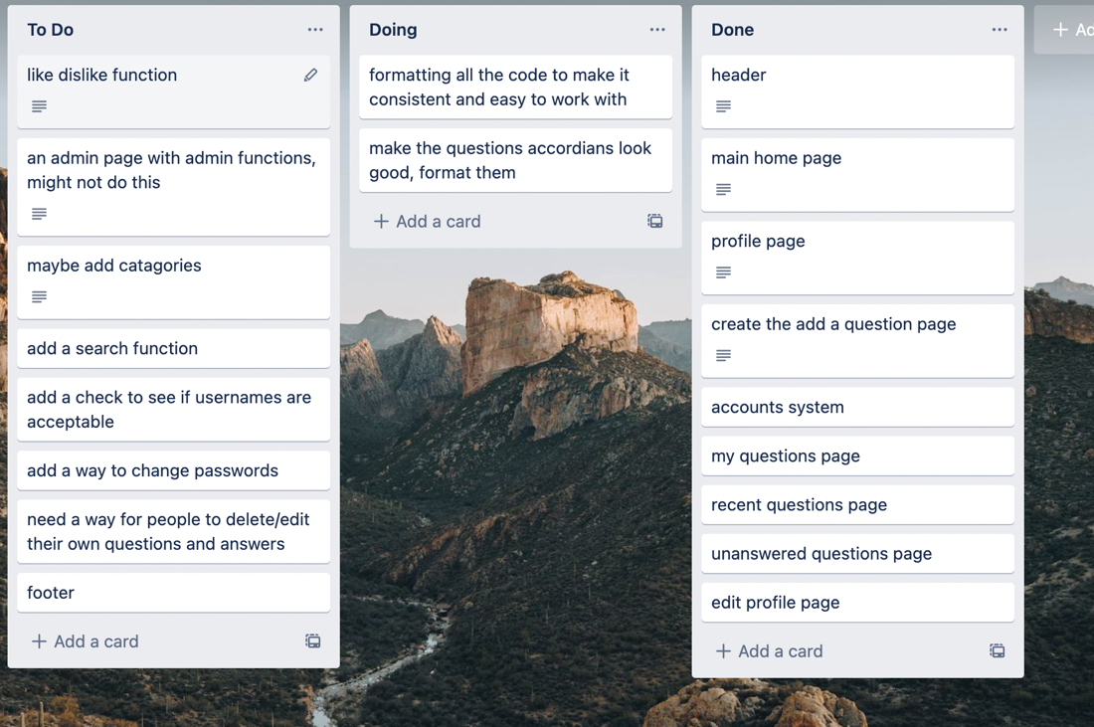

Week 6

I also added a way for the admin to delete any questions and any answers, useful if something inappropriate is posted.

I also added a way for users to delete any questions or answers they posted themselves, useful for users who decide they no longer want a post visible and want to remove it.

I now need to add a way for users to edit their posts.

I started to work on formatting the code, but I gave up as I need advice on the best way to do so, for example, industry standards.

Began to make some of the sites look better with css and Bootstrap but hardly anything.

Broke something that needs fixing next week, with an undefined variable, shouldn't be hard to fix.

Next week I plan on fixing the issue and that’ll be all for that week because it will be the middle of the holidays.

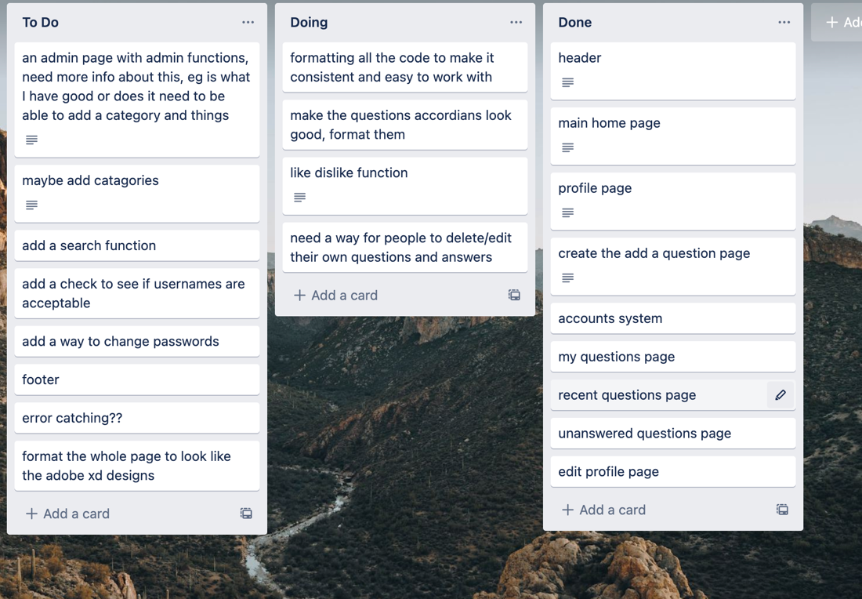

Week 7 (ended 23rd April)

Fixed an issue with an undefined variable, had just changed the name of a column in the questions table and not changed in the code where I set it as a variable. Not difficult to fix.

Next week probably won’t do anything as I'm happy with where I am, and it is still the school holidays.



Week 8 ended 30 April

Last week of school holidays nothing was done this week.

Week 9 ended 7 may

This week my life was extremely busy so very little was done as I just didn’t have enough time and energy to get into it, next week will also probably be very busy so this might be a slightly slow period in the project. In class this week I did work on adding an edit questions function to the site and made the decision not to add an edit answers option as this could lead to people changing their controversial replies in attempts to make themselves look like they were in the right a similar reason to why Instagram won't let you change them.

Next week I plan to continue this work by adding an edit question page.

Week 10 ended may 14

Beginning to get to the end of the project. Potentially only one or two things left to do before I start tidying up the project.

This week I did heaps.

The first thing I did this week was add a page where users could edit their questions, or the admin could edit any questions. This caused some problems but was done after a day or two of struggle, a simple stupid fix.

Next, I created a way for admins and teachers to create accounts for students, I also, created a way for everyone to change their password and made sure to hash the inputted passwords before they entered the database. Then made it so only admins or teachers could change their status/occupation so that students were not making themselves teachers. Next, I added a category system and started this by ensuring that when asking a question everyone must choose a category, next I put the same code into changing a question, so users could change the category of the question they asked. I then added code to the main questions/common content so that users could filter results by categories, this was extremely difficult and might have been the hardest thing I've done yet, just due to the difficulty of getting my head around all the different conditions. I then also added an echo to display the category name of each question on the accordion head thanks to feedback from Spencer.

I then decided that I shouldn't let two people have the same usernames, so I added a check for whether a username was taken, both when accounts were created and when passwords were changed.

Next, I fixed the footer, so it stuck to the bottom of the page, this required some figuring out as the bootstrap website was not helpful.

Then I changed some things based on feedback from Spencer, removed the extra home button and added a filter title so that users could see what filter they had selected at the top of the page. Also changed the colour of the dropdown icon to a more visible white based on feedback.

changed some of the hard-coded drop-down lists to lists that used ‘do while there are still rows in the rs’ functions, and user info from the categories database, also moved a lot of common content, like the redirect if not logged in and the DB connect into a new file to be included when needed, which was most pages so a lot of lines of code were saved here.

Then I realised because I had taken out the extra home button based on feedback; I should add a ‘back to all questions’ button to make it easier to understand. I also decided that admins should be able to create teacher profiles and profiles for other admins, so I made that a reality. Next was something that took me a very long time to do, I had gotten into a habit of setting things out of the rs as variables and using those variables in the rest of my code. For example, I was setting $example = $example_rs[‘example’]; instead of just using $example_rs[‘example’]; everywhere. So, I removed everywhere where I did this and replaced those useless variables with $example_rs[‘example’];. This took ages but saved a lot of code and made the site way more efficient.

Next, I read the checklist and decided I should add a way for admins to add categories and delete them. This proved problematic as by deleting a category I would have to delete the questions and answers also in that category or else they would have unassigned categories. So, I went through and did this using extremely confusing if statements that I was hardly even following when writing it but eventually it all started working.

Finally, the last thing I did this week was change all the variables that didn't have meaning to variable names that had meanings.

A lot was done this week. I could probably end it here, but there are maybe one or two more things id like to do just because I want to learn how to do them so I might as well put them in. Aside from that, I must format and make it all look good, as well as do the rest of the commenting. When that is done the actual coding should be finished and I can focus on getting the paperwork done and worrying about getting good marks.

.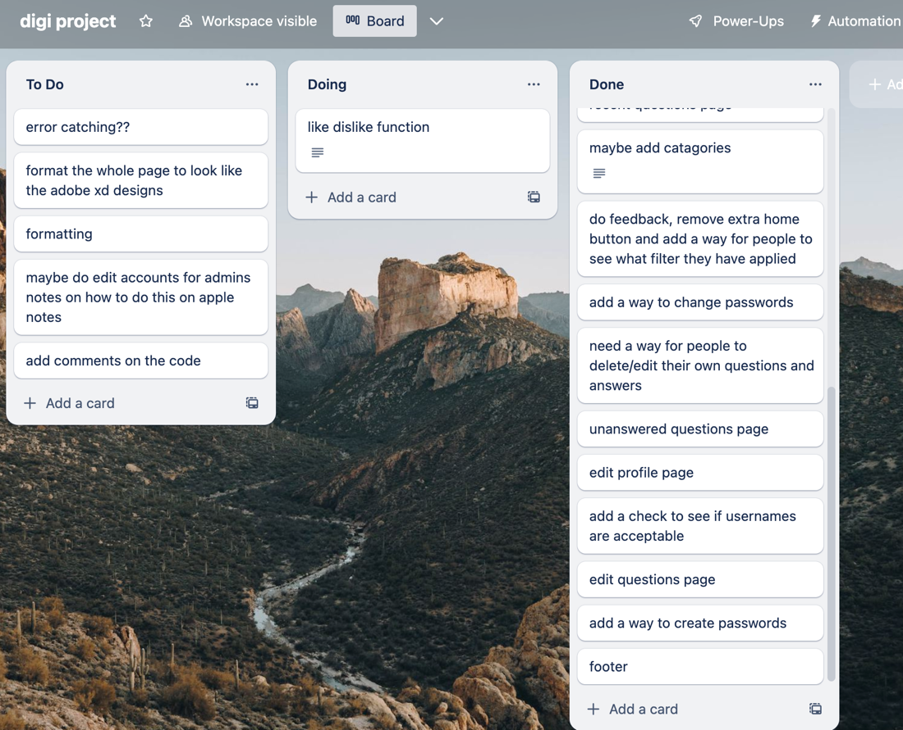

Week ended May 21 and week ended May 28 very little was done as the website is nearing completion. Weeks 11 and 12.

Week ended 4 June. Week 13

This week cleaned up the database a lot, and I followed a camel format, I changed the naming of multiple columns, I changed the field lengths. The website was also made available to a larger group of people for feedback.

Week ended 11 June. Week 14

This week I finished everything off. I started by listening to feedback from those I sent my website to, I fixed the places where it was broken, by adding checks for things like blank text areas being submitted and preventing too many characters from being submitted in the text boxes for the database to handle. The data in the database was also cleaned up to only include that which was relative. I then added comments through all the code.

This week I also made the year level visible on the answers and questions of the user who submitted it and whether the user was a student.

## Final review

#### Summary and evaluation of the process’’’’’’;

My process was different from a lot of other students because I had never made a website before, being new to digi tech in year 13 so my process involved a lot of learning and a very large amount of guessing and ‘learning on the job’. It all started with designing the site on adobe xb and learning a lot about what was expected of the website I was going to make. Adobe XD proved tricky to learn but easy once you got the hang of it, and I got the designs done quickly, however, due to feedback and changes in my preference these designs changed a lot throughout the process and eventually ended up as what I have now. Next, I began coding, using the Trello board to work out every single little task I had to do, and this practice of breaking down the tasks into small easy-to-manage tasks allowed me to stay motivated and get through the work efficiently. Being new to coding and web development I soon found that I picked things up easily and would often spend some time learning to do something once and then implementing it four or five more times across different parts of the project. I've found that now I could probably write the code for the same website in a fraction of the time as it all seems so simple looking back. The structure of my site centred around one page I had mistakenly named ‘main structure’ instead of the index and all of my different pages were included on that index page with a complicated series of if statements. The biggest problem I ran into was when I tried to make the site more efficient by merging three very long and very similar pages into one, thing genuinely took hours and an extreme amount of thought and effort and multiple attempts where I would have to go back to GitHub for a new copy of the old code every time I broke something major. This was the hardest problem to solve but it wasn't the only one, I can remember multiple times when I struggled with an uncooperative section of code for ages before realising that I had accidentally missed a comma or a semi-colon. These little problems come up everywhere but every time they were solved, and every time I learned more about the issues I had created through these problems. Feedback was also important and helped massively when identifying ways to better meet my relevant implications and when finding places where the site would break. In the end, it took me 14 weeks to complete the project, some of which didn't involve any work at all and 2 of which involved, I would guess 90 percent of the total effort, I learned that this type of project is the way I work best, without any pressure to do heaps of work on any particular day just consistently working away as a project with occasional spontaneous bursts of effort. I was also advantaged by sitting at a table with a group of my target audience so could receive constant feedback. In the end, I completed the site to my satisfaction, in a similar way to what I had envisioned, and while properly satisfying the necessary relevant implications.

#### Summary and evaluation of your selection of tools throughout the project

Throughout the process of creating this website, I used Trello to plan and manage all the tasks I had to get done and this proved to be an excellent way to do this. It allowed me to manage the workload effectively and stay motivated to chip away at the task and get it done one piece at a time. For example, things like ‘create and add the ask a question page and form’ and ‘add categories’ and ‘add a check to see if usernames are acceptable’. The best thing about Trello proved not actually to be the way it helped manage the project but instead, the way it would motivate me, I would be sitting down bored and unwilling to work until I would open my laptop and find the Trello board to see that there was something that was reasonably straight forward and wouldn't require a lot of focus to knock out quickly, and this would often lead to another task after the first was finished and I found I would quite quickly go from unmotivated too willing to work hard for multiple hours in a row. Below is the final Trello board. 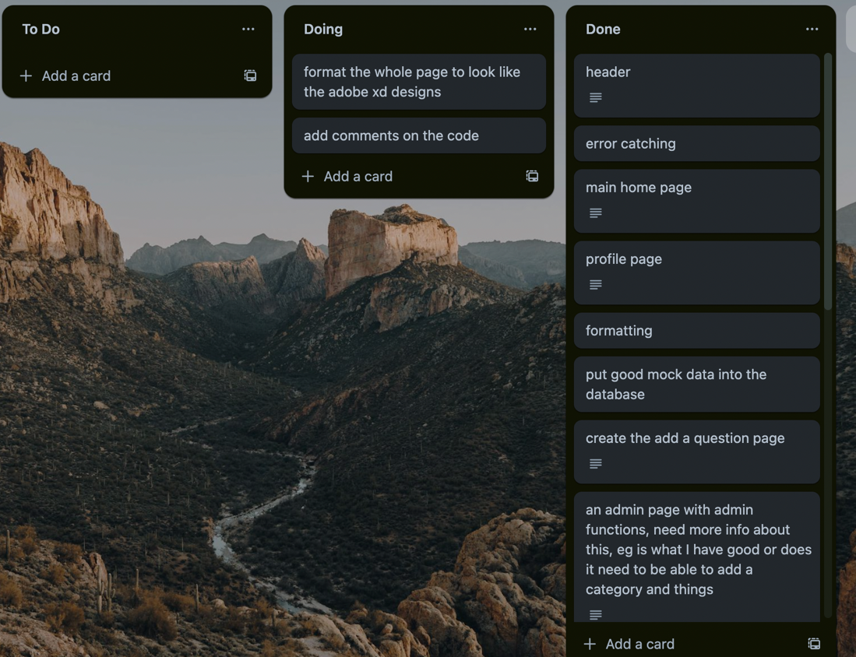

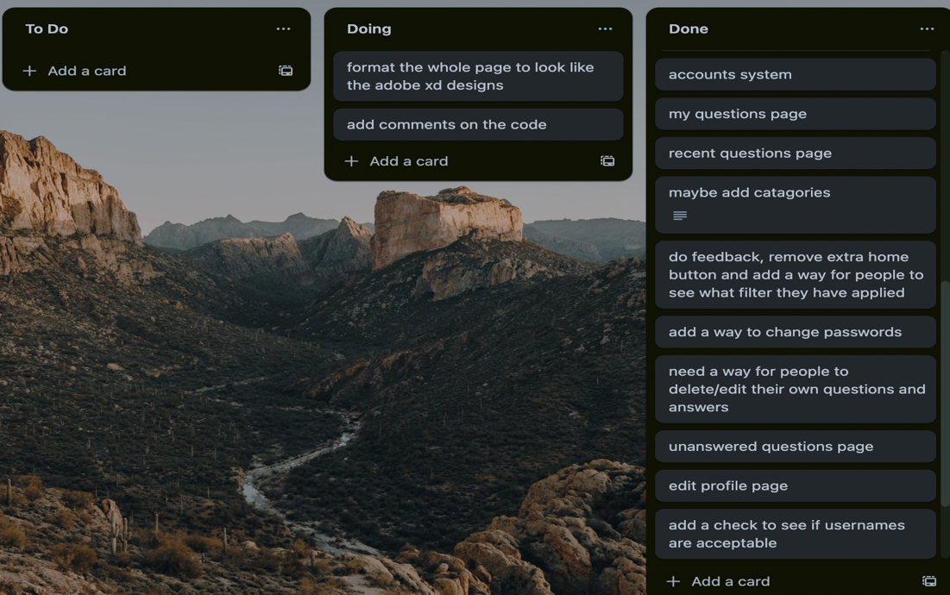

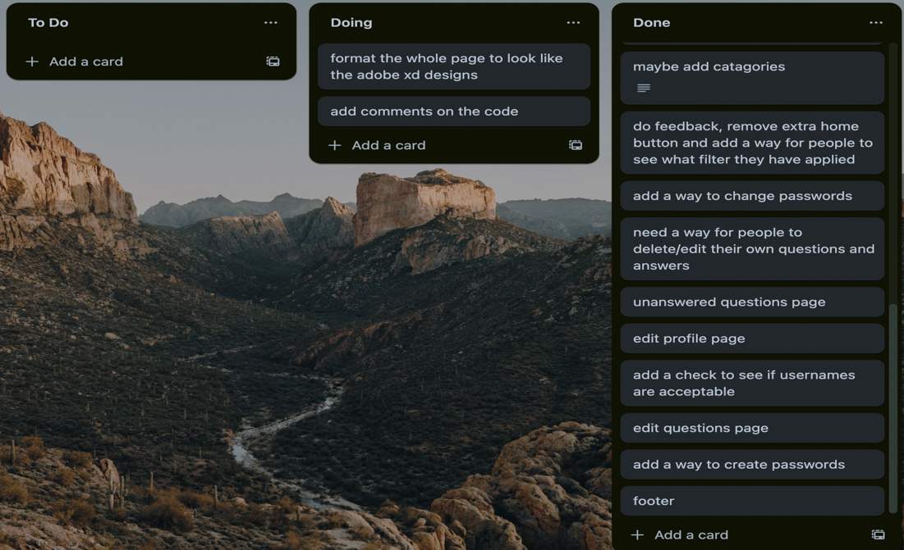

I used Db designer to design my database and visualise how they would all link together, it allowed me to see what columns could potentially be removed to make the database more efficient and also allowed me to plan all the links, understand where some things would need both a name and an ID if they were going to be assigned to multiple different rows of data in the table. The program worked very well and was simple to use and understand, the only trouble I had was figuring out how to create links, which didn't take me too long to get, so overall the program was perfect and worked exactly how I wanted it to.



I used Adobe XD at the beginning of my process to get down exactly how I wanted my site to look, I designed them and chose the designs before knowing exactly what makes the site would involve as I have never made a website before. This proved to be a challenge immediately as I knew exactly what I wanted my questions to look like but had no idea how to make them drop down the way I wanted. Bootstrap was used to use their accordion feature, which allows sections to be clicked and a dropdown section to appear, which was exactly what I wanted. So, these designs on Adobe XD gave me direction and a goal in terms of visuals rather than functionality. Designing the site beforehand also allowed me to show my stakeholders what I was trying to make my site look like, so when I was asking for feedback, they knew what I was trying to get to. It also allowed me to get feedback on what I thought the site should look like from the stakeholders I go to for feedback. Abode XD also allowed me to change what I wanted my designs to look like on the fly and see what those changes would look like without drastically changing my code, just to see if maybe it was better. The program is great, I had never used it before, but it was an excellent choice, very easy to use, easy to learn and logical. Additionally, it saved all the work well, had lots of useful tools, and allowed me to see all the screens at the same time as shown in the photo below. In the end i did choose to change the colour scheme away from green to blue because I decided it looked better, the layout and design was in the end all the same though.



To save the project I used GitHub, which served as a place to store the latest copy of my work and old copies of work, and to remember what I had done so I could complete the weekly review accurately. Keeping old copies of my work allowed me to go back to old versions of the code if I broke the site in any way or if I did a lot of work and decided it wasn't better than the old version. The main instance when I had to go back and get an old copy happened around the middle of the project. I had just made the ‘my questions’, ‘recent questions’, and ‘unanswered questions' pages’ which were all very long, with maybe 200 lines of code in each of them. The problem was all three of those pages were very similar in terms of the code, however, they had small but very important differences. I knew the code could be more efficient if I combined all three of these pages into one called ‘common question content’ and used if statements to accommodate for the minor differences. The issue was finding what needed to be included in the main content and what needed to remove. This turned out to be tricky and I got it very wrong the first time, so it was good that I had a backup to go back and get the code that worked to try again, and it probably saved me a good hour of stressful work.

I used Freeparking to host the website online. This was through the Stac Digi website. This allowed me to send out my site to a larger group of people for feedback, which proved to be a great way to identify how the site could break. For example, very quickly someone discovered a link to an email didn't work as expected, using Freeparking to help me test allowed me to understand exactly what was wrong with the site. This was a simple, quick and easy fix but would have been a problem if it hadn't been caught.

#### How did your outcome successfully meet the requirements and relevant implications?

The relevant implication of privacy was successfully met in my site as the sensitive information that users inputted into my site was protected. An example of this was the inputting of passwords which were then sent to an unseen page both to be inserted into the database and to hash the password before it was submitted. Doing things this way means if someone maliciously managed =]to get into my database, they would not be able to use any of the user's important data as it would be impossible to understand. The users were informed when their data would be displayed on the site and were able to make informed decisions based on their personal preferences to do with privacy. Users were also protected as when sensitive information was requested on the website it always required a user to log in and only displayed the profile page of the current user instead of whatever user was in the get array for example. This meant only those who were meant to could see and change the user's data.

The relevant implication of functionality was met in this website as all the features and functions of the site worked perfectly every time and every feature you would expect to be on the website is there. I addressed this implication first by ensuring all the necessary features were included and then by ensuring the site had no errors and worked on all platforms. This caused some issues as there were many errors and places where the site broke, but part of the process was fixing them. For example, I was given feedback telling if the site would break if someone submitted a comma into the database. This needed fixing so I learned about the real escape string and added it to every place where a user could enter text into the database which allowed for the use of things like commas. Another example of an issue I fixed to make the site more functional was when I was told the email link on the footer did not work, this means that a function on the site doesn't work, so to ensure functionality I fixed it and had it working perfectly. I have done my best to ensure that all the functions work as expected and the site cannot be easily broken, certainly not by an everyday user who is not trying to do so.

I addressed the relevant implication of usability from the beginning by ensuring that everything was extremely simple and logical, everything worked as you would expect, and nothing was overly complicated. Throughout the process I worked to make the website easier and easier to use, this was primarily done through the use of feedback, I regularly gave my site out to my dedicated stakeholders for feedback and sometimes specifically asked them to think about how easy it was to use and understand, and I ended up getting some great feedback that allowed me to better address the implication. For example, I received feedback that one of the buttons on my navbar was unnecessary and confusing as it was essentially just another home button with different words. So, I removed the second button to make it easier to use and less confusing. I found many small ways to make the site slightly easier to use during the process. For example, I added alerts throughout the site informing users of issues that have come up, for example, if a username is taken the user is redirected and an alert will appear telling the user exactly what went wrong so they don't struggle to use the site. Overall, I listened to feedback, kept it in mind when designing the format and functions, and found lots of small ways to make the site easy all to meet the relevant implication of usability. Usability heuristics were addressed in the usability section above (on page 6)

I addressed the relevant implication of future-proofing by ensuring that the database followed conventions and was easy to follow and update as necessary. I used camel case for everything in the database to keep it consistent and easy for any other person who took over being an admin to follow. I also ensured the database allowed room for the number of entries I envision the site getting in the near future, of course, this can be changed later if it is needed but it likely won't need to be. The user admin panel was also designed with future-proofing in mind. It allows for the creation of new accounts including new admin accounts, so the site can be handed over as many times as is needed. There is also a way to add new teachers and new student accounts and even a method for adding and updating categories as new subjects are potentially added to the school curriculum. Simply, the future-proofing implication was met when ideas such as the future maintenance of the database and the future of the target audience were considered.